**Some algorithms and concepts**

**1: Pattern Matching Algorithm:**

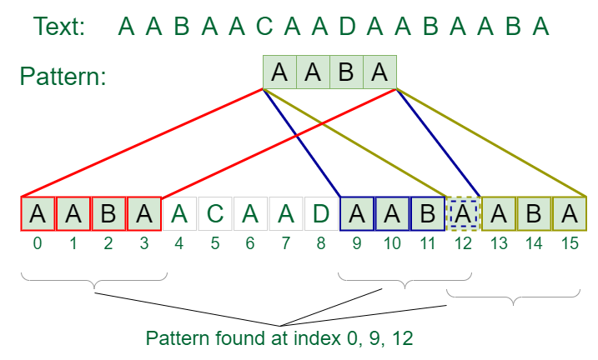

* **Naïve based approach:**
* **KMP algorithm**
* **Rabin Karp algo**

**Gfg link:** <https://www.geeksforgeeks.org/introduction-to-pattern-searching-data-structure-and-algorithm-tutorial/>

**2: Difference between prims algo and Kruskal algorithm**